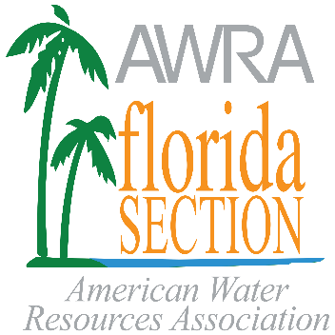
Florida Section, American Water Resources Association, Inc.

The Rosanne Clementi Education Program

Buddy & Laura Blain High School Scholarship

The Florida Section of the American Water Resources Association (AWRA Florida) is a multidisciplinary professional organization concerned with the conservation, development, management and utilization of fresh and estuarine waters and related resources together with their environmental aspects. AWRA Florida annually offers a $1,000 scholarship to a high school senior in Florida who has demonstrated outstanding achievements in academic performance and community involvement and has an intent to pursue academic studies in a water resources related field at a college or university in the state of Florida. The scholarship recipient will also be awarded a student membership to AWRA Florida for the following year.
The application deadline for this award is April 30, 2022 with the award being announced following the August 2022 AWRA Florida Board of Directors meeting. The Scholarship will be awarded upon confirmation of enrollment in a college or university in Florida. All students are eligible to apply, whether they attend public, private or home schools. Students related to AWRA members are eligible to apply.

Application Requirements and Instructions:
APPLICATIONS MUST BE SUBMITTED ELECTRONICALLY AS ONE PDF FILE.
(You can have the letters of recommendation be sent directly to us, separately from the rest of your package)

- Complete the application. All parts of the application must be completed to be considered.
- Application packages must be emailed to AWRA Florida no later than April 30, 2022.
- Provide two (2) letters of recommendation that address why you are the best candidate for this scholarship. At least one of these two (2) letters must from an administrator or instructor at your high school. The other letter may be from a member of the community in a field related to water resources.
- Provide a copy of your most recent high school transcript/grades. An unofficial transcript is acceptable.
- Include a brief (no more than two (2) single-spaced pages) essay addressing why you are planning academic studies in the water resources related fields, either the physical sciences or environmental science related (e.g., geology, engineering, ecology, marine biology, etc.). Be concise, but thorough. Please address the following topics in your essay:
- What is your interest in water resources?
- What activities have you engaged in relating to water resources, be they in school or through extracurricular activities?
- What are your professional goals and aspirations?
- What do you plan to contribute to conservation, development or management of water resources?
- Provide any additional information you feel supports your request for this scholarship.
- Application packages must be combined into a single PDF file, named with your last name, the award name and year. (e.g., “ApplicantLastName_Blain_2022.pdf”).
- Submit the application package to awra@awraflorida.org with the subject line “2022 Blain Application”.
If you have any questions or do not receive a receipt confirmation email within 24 hours of submitting your application, call or email Gordon Brown at (352) 246-1865 or gbsailorny@msn.com.

Selection Criteria for the applicant to consider regarding content to include:

- Interest in water resources: Evidence of interest in Florida’s water resource issues, through academic and extracurricular activities.

- Academic performance, including any honors or awards.

- Research interests (if applicable): Research under way or accomplished, relevance to the field of water resources, and importance of the research to today’s pressing problems in water resources.

2022 Buddy & Laura Blain
High School Scholarship Application

Student Name:
Parent/Guardian Name:

High School Name:

School Address: City State Zip

Home Address: City State Zip

Student Phone: ( )

Parent/Guardian Phone: ( )

Student Email Address:
Parent/Guardian Email Address:

Expected High School Graduation Date:
Name of College you plan to attend:
Expected College Start Date:
Expected College Graduation Date:

How did you hear about the Buddy and Laura Blain High School Scholarship? Specifically, from whom? With what organization?

See next page for certification

APPLICATION CERTIFICATION

I hereby certify that all the information submitted on this application is true and accurate to the best of my knowledge. I understand that submitting non-factual information will automatically disqualify me from any consideration for a scholarship.
Applicant Signature: Date

Parent or Guardian Signature: Date

Parent or Guardian Printed Name:

